**2. Selection Problems (IF ELSE, ELIF)**

**Task 1:**

**Plan:**

1. Define variable temp as integer from user input
2. Check to see what condition temp meets (in range), then define variable state.
3. Output (temp, state)

**Pseudocode:**

Temp 🡸 input as integer ("Enter the number of current temperature: ")

If temp <= 0:

State 🡸 “Solid”

Else if temp in range (1,100):

State 🡸 “Liquid”

Else:

State 🡸 “Gas”

print ("At", temp, "degrees centigrade, water will be a", state)

**Variables table:**

|  |  |  |
| --- | --- | --- |
| Variable Name | Data type | comment |
| Temp | Integer | Stores input from user as integer |
| State | String | Stores string “solid”, “liquid”, or “gas” |

**Screenshot evidence:**

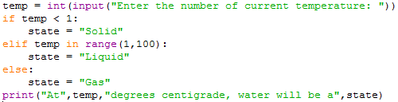

In the screenshot above the temp variable asks user to enter a temperature, that temperature is then check against 3 conditions, and the state variable is defined.

I came across an error when testing; I found that I had not validated the user input. So I added in a while loop with a try and except statement to make sure temp is an integer as you can see in the screenshot bellow.

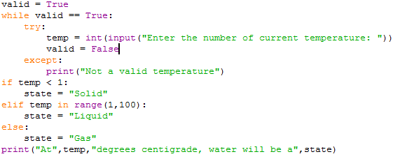

**Sample runs (Output):**

**Solid:**

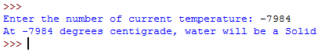

**Liquid:**

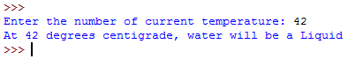

**Gas:**

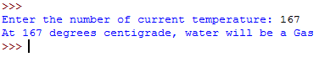

**Error:**

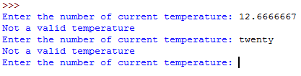

**Flow charts:**

START

No

print ("At", temp, "degrees centigrade, water will be a", state)

State 🡸 “Gas”

No

No

Yes

Yes

State 🡸 “Liquid”

State 🡸 “Solid”

ELSE

Else if temp in range (1,100)

If temp <= 0

Temp 🡸 input as integer ("Enter the number of current temperature: ")

Is temp an integer

Yes